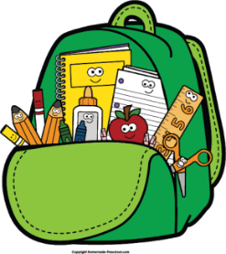

Dear Kindergarteners,

Welcome to Kindergarten at Three Bridges School! I am absolutely delighted to be your Kindergarten teacher this school year. I hope you are ready to learn lots of new things and meet new friends, too! We are going to have a blast reading, writing, counting and discovering together.   
I hope you are excited to see your new classroom. We have a little reading corner, a play kitchen, an art center, blocks, Legos, and so much more!

A Little Bit About Me…

This will be my seventeenth-year teaching. I have taught kindergarten for fourteen years and second grade for three years. I live in Clinton with Mr. O’Connor and my two children Kendall (age 10) and Hunter (age 8). We enjoy hiking, playing sports, swimming, going to the beach, and watching football. I also enjoy baking cookies and eating them, too. And, of course, I love teaching Kindergarten!!!

I am super excited to learn all about you and see your smiling faces in September!

Love,

Mrs. O’Connor